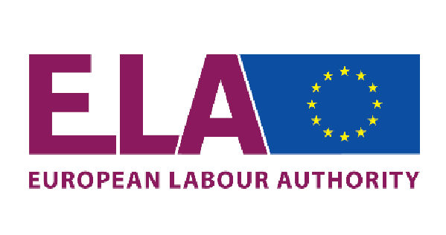
Brussels, 20 January 2021

ELA(2021)

ELA - Working Group on Information

Country-Delegation | Status | Last Name | First Name | Affiliation
Austria | Member | MURR | Robert | Ministry of Labour, Family and Youth (BMAFJ)
Austria | Alternate | NEUBAUER | Walter | Ministry of Labour, Family and Youth (BMAFJ)
Belgium | Member | DEPAUW | Bruno | National Social Security Office
Belgium | Alternate | VANDENAMEELE | Vincent | Flemish Department Work and Social Economy / Flemish Social Inspection
Bulgaria | Member | BUTSEVA | Rumena | National Employment Agency
Bulgaria | Alternate | DIMITROVA | Irena | Labour Inspectorate Executive Agency
Croatia | Member | FISEKOVIC | Olivera | Ministry of Labour and Pension System
Croatia | Alternate | KEZELE | Patricija | Employment Service
Cyprus | Member | KAFOUROS | Antonis | Ministry of Labour, Welfare and Social Insurance
Cyprus | Alternate | IOANNIDOU | Yolanda | Labour Officer  Department of Labour, Ministry of Labour, Welfare and Social Insurance
Czech Republic | Member | SILOVSKÁ | Petra | Ministry of Labour and Social affairs
Czech Republic | Alternate | NĚMEC | Ladislav | Directorate-General of the Labour Office
Denmark | Member | SEERUP | Rikke Mark | Agency for Labour Market and Recruitment
Denmark | Alternate | STRØBECH | Trine | Agency for Labour Market and Recruitment
Finland | Member | PÄIVI | Kantanen | Ministry of Economic Affairs and Employment
Finland | Alternate | HUHTAMÄKI | Henna | Ministry of Social Affairs and Health
France | Member | REDT- GENSINGER | Jonathan | Ministry of Labour
France | Alternate | VAURES | Daniella | Ministry of Labour
Germany | Member | FARZAN | Jan | Federal Ministry of Labour and Social Affairs
Germany | Alternate | - | - | -
Greece | Member | KIOURKATIOTI | Agathi | Labour inspectorate
Greece | Alternate | PREARI | Christina Maria | Labour inspectorate
Hungary | Member | VARGA | Károly | Employment Attaché  Permanent Representation of Hungary to the EU
Hungary | Alternate | JÁRAI | József Krisztián | Ministry for Innovation and Technology
Ireland | Member | ROSS | Maria | Workplace Relations Commission
Ireland | Alternate | MORAN | Eltin | Department of Employment Affairs & Social Protection
Italy | Member | TORLINO | Gerardo | Ministry of Labour
Italy | Alternate | LUCCHETTA | Ivo | Ministry of Labour
Latvia | Member | KIKUTE | Lelde | State Employment Agency
Latvia | Alternate | - | - | -
Lithuania | Member | POLIJANCUK | Jelena | Ministry of Social Security and Labour
Lithuania | Alternate | KURELAITYTĖ | Eglė | Ministry of Social Security and Labour
Luxembourg | Member | FURLANI | Patrice | Inspection du travail et des mines
Luxembourg | Alternate | - | - | -
Malta | Member | AZZOPARDI | Anthony | Department For Industrial and Employment Relations.
Malta | Alternate | GRECH | Omar | Department For Industrial and Employment Relations.
Netherlands | Member | DIJKSTRA | Annette | Social Affairs and Labour Inspectorate (Inspectie SZW)
Netherlands | Alternate | VAN DER VOORN | Koen | Social Affairs and Labour Inspectorate (Inspectie SZW)
Poland | Member | SWEKLEJ | Magdalena | Ministry of Economic Development, Labour and Technology
Poland | Alternate | - | - | -
Portugal | Member | ROQUE MARQUES | Vera | Direção de Serviços de Orientação e Colocação  Departamento de Emprego
Portugal | Alternate | - | - | -
Romania | Member | MIHALCEA | Camelia | National Agency for Employment
Romania | Alternate | TUDORIE | Andreea Cristina | Romanian Labour Inspectorate
Slovakia | Member | JAMRICHOVÁ | Lucia | Ministry of Labour, Social Affairs and Family
Slovakia | Alternate | BERINEC | Lukas | Ministry of Labour, Social Affairs and Family
Slovenia | Member | LOGAR | Lucija | Ministry of Labour
Slovenia | Alternate | TROKIČ | Sabina | Ministry of Labour
Spain | Member | DE ALARCÓN PAREJA | Virginia | Labour and Social Security Inspector
Spain | Alternate | RODRÍGUEZ GARCÍA | Noel | Labour and Social Security Inspector
Sweden | Member | DELAND | Madeleine | Public Employment Service
Sweden | Alternate | HAGELSTEDT | Viktoria | Agency for Digital Government
EU Level Social Partners
Business Europe | Member | HOUGAARD | Trine Birgitte | Confederation of Danish Employers
Business Europe | Alternate | SASSI | Stella | Confcommercio
ETUC | Member | DISTLER | Katrin | DGB
ETUC | Member | PREISA | Natalja | LBAS
ETUC | Alternate | BUELEN | Werner | EFBWW
ETUC | Alternate | MALPASSI | Andrea | INCA CGIL
EU Institutions
European Parliament | Member | KROON | Brigitte | Tilburg University / Department of Social Law and Social Policy
European Parliament | Alternate | CREMERS | Jan | Tilburg University / Department of Social Law and Social Policy
European Commission | Member | LUCHICI | Andrei | DG Employment
European Commission | Alternate | PEREZ ALVAREZ | Laura | DG Employment
__________

