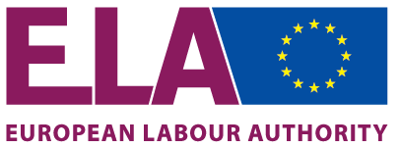
Agenda
Second Meeting of the Working Group on Inspections, 5 March 2020
Rue de Spa 3, Room 02/P094, Brussels, Belgium

No | Time
 | 09:30-10:00 | Registration and welcome coffee
1 | 10:00-10:15 | Introductory round table
2 | 10:15-10:45 | - Adoption of the Agenda  - Short reflection on the meeting of 6 February  - Introduction of the purpose and goals of today’s meeting
 |  | Planned activities
3 | 10:45-11:15 | Presentations by Commission and Member States on the activities during the Week of Action #EU4FairWork and the role of the ELA
 | 11:15-11:30 | Coffee break
 |  | Draft Model agreement
4 | 11:30-12:15 | Presentation and discussion on the updated draft Model Agreement - ELA/WGINSP/2020/003 Rev1
 |  | Draft Post-inspection report template
5 | 12:15-13:00 | Presentation and discussion on the updated draft Post-inspection report template for concerted and joint inspections (CJIs) - ELA/WGINSP/2020/005 Rev1
 | 13:00-14:00 | Lunch
 |  | Draft Workflow guidance for inspections
6 | 14:00-15:00 | Presentation and discussion on the updated draft Workflow Guidance for Member States to request the coordination and support of the ELA for CJIs - ELA/WGINSP/2020/004 Rev1 and for ELA to suggest to Member States to carry out CJIs - ELA/WGINSP/2020/008
 |  | Draft Workflow guidance for proposing cases
7 | 15:00-15:30 | Presentation and discussion on the draft Workflow guidance for social partner organisations at national level to bring cases to the attention of the ELA - ELA/WGINSP/2020/009
 | 15:30-15:45 | Coffee break
 |  | Key Performance Indicators for concerted and joint inspections
8 | 15:45-16:30 | Presentation on KPIs and discussion on the KPIs for concerted and joint inspections
 | 16:30 | AOB & Closing

